Date: July 19, 2022
To: Weber County Board of County Commissioners
From: Scott Mendoza
Community Development Department
Agenda Date: July 26, 2022
Subject: Request to declare certain parcels, within and near Marriott-Slaterville City, as Surplus Property
Attachments: A - Vicinity Map with Aerial Photo

_____________________________________________________________________________________

Summary:
Marriott-Slaterville City has reviewed county land ownership records (that show land ownership within/near the City boundary) and has determined that there are fifteen Weber County owned parcels that can be better utilized and maintained if owned by the City. Fourteen of the fifteen parcels (or portions of the parcels) are situated in or along future and existing road rights-of-ways. The one remaining parcel that lies outside of a road corridor is located next to an existing subdivision’s storm water detention pond that is owned and maintained by Marriott-Slaterville City. See Attachment A for a vicinity map and an approximate location for all parcels.
The parcels that Marriott-Slaterville City has inquired about are identified by the following tax identification numbers:

Parcel ID# | Sqft | Parcel ID# | Sqft | Parcel ID# | Sqft
- 15-217-0005 | 2,613 | - 15-042-0014 | 1,307 | - 15-065-0055 | 10,890
- 15-008-0050 | 26,571 | - 15-061-0053 | 76,230 | - 15-035-0025 | 5,227
- 15-029-0077 | 102 | - 15-188-0005 | 7,841 | - 15-035-0029 | 1,050
- 15-036-0033 | 5,227 | - 15-036-0015 | 6,534 | - 15-062-0084 | 12,197
- 12-102-0007 | 3,920 | - 15-061-0051 | 422,532 | - 15-060-0091 | 6,098

Weber County has no intended use for the listed properties; therefore, it is recommended that the parcels be declared as surplus and offered to Marriott-Slaterville City. In order to convey real property, the County Commission must first take action to review and officially declare parcels as surplus to the county’s needs.

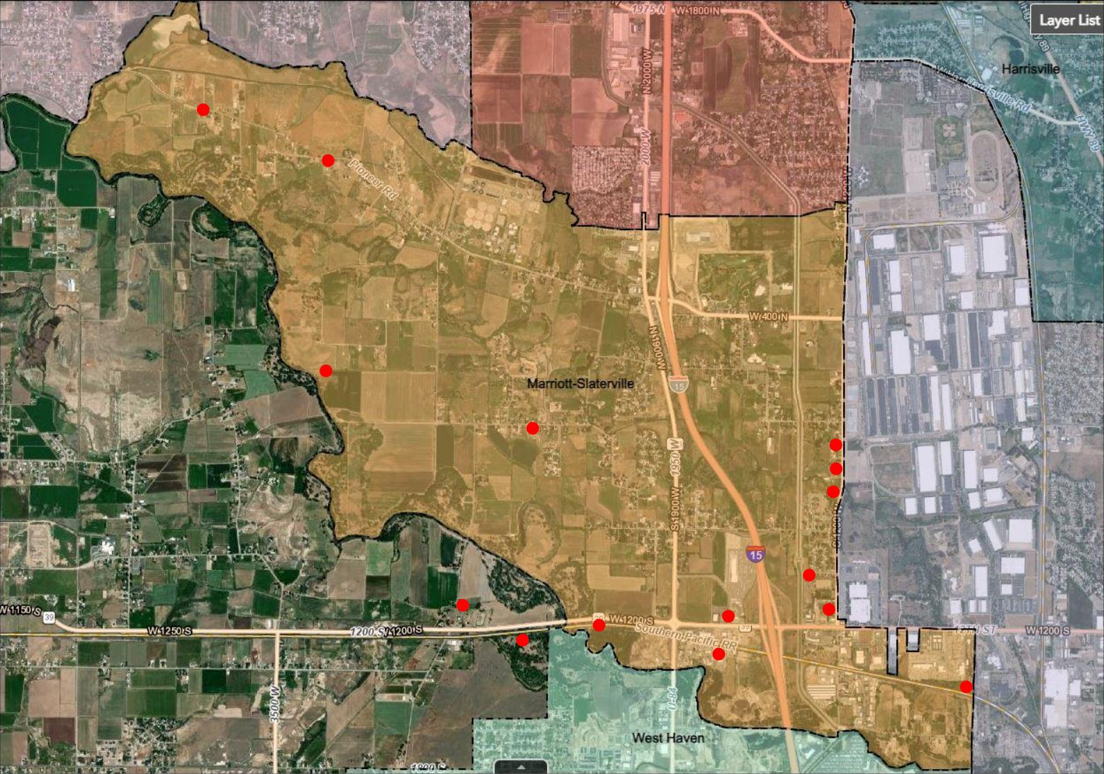
Attachment A

